- Translate these words:
Out |  | Suddenly
Hear / heard |  | Terrible
Scream |  | Cry
Take/took |  | Stone
Stick |  | Afraid
Hold/held |  | Ready
Come/came |  | See/saw
fight |  | Have to / had to

- Read the text and decide whether the sentences are True or False:
One night I was with my friends out. And suddenly we heard a terrible scream. I thought that a child cried. I told my friends we had to help it. We took big stones and I took a long stick. We were afraid, but we went after the scream. I held the big stick and I was ready to use it. When we came closer we saw two cats fighting.
- It was night.
- They were not at home.
- They heard a child.
- They ran away.
- They took a stick and stones.
- They were not afraid.
- They saw two children.

- Grammar up the text:
One night I BE with my friends out. And suddenly we a terrible . I that a . I my friends we HAVE TO help it. We big stones and I 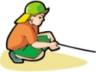. We , but we 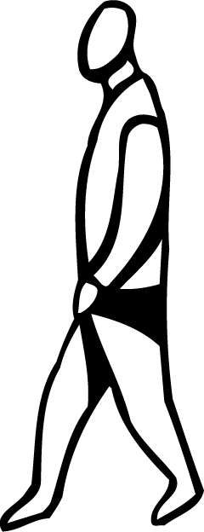 after the scream. I and I BE ready to use it. When we COME closer we 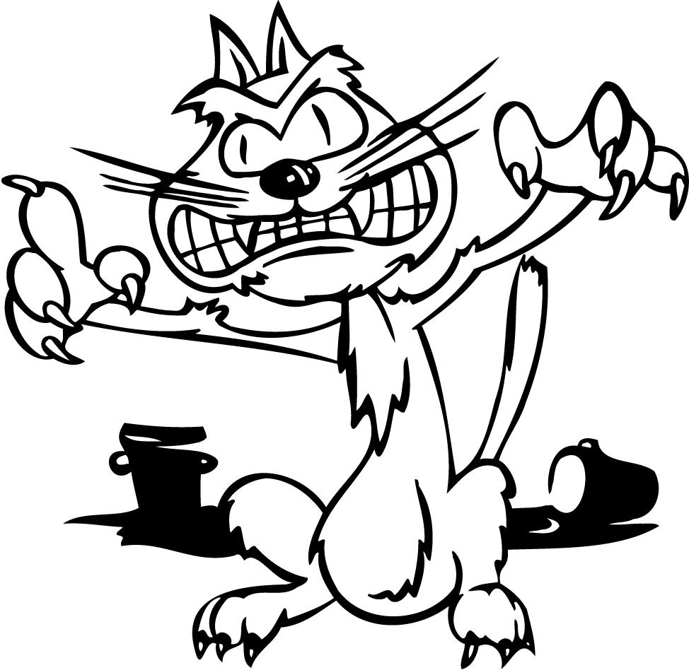 .

- Solve the crossword
5.
6. 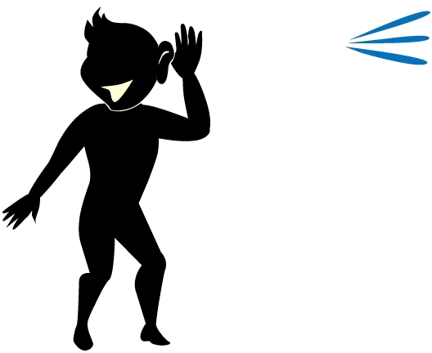
7.
8.

1. I a long stick
2.
3.
4. 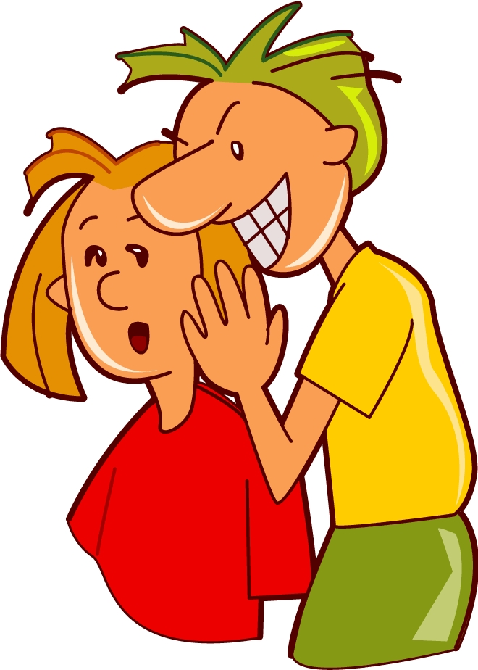

- Reconstruct the text:
One ni_________ I was with my friends ou____. And sud___________ we __________ () a ter_________ sc___________. I ___________ () that a ________ __________ () . I ___________ () my friends we ha____ to help it. We ___________ () big sto_________ and I ________ ___ _________ ____________ () . We __________ _________ (), but we _____________ () after the scr___________. I _______ ___ ______ _________ () and I was rea________ to use it. When we ca________ clo________ we _____________ _______ _______ ___________ ( ).
1.
2.
3.
4.
5.
K
6.
7.
8.
O
N
E

